

**SCHOOL OF ENGINEERING AND TECHNOLOGY**

**Train Ticket Booking Website**

*Database and Management System:15BCS-1DB21T*

**BACHELOR OF TECHNOLOGY**

in

**Computer Science & Engineering  
(Full Stack** and **AI** & **ML)**

By

**Rishu – 220BTCCSE076**

**Manshi – 220BTCCSE145**

**Date of Submission: 29-04-2024**

**Submitted to – Dr. Sherry Verma**

**Journey Junction**

Abstract:

This project aims to develop a train ticket booking website, focusing on creating a user-friendly interface for customers to easily search for and book train tickets. The project utilizes SQL for database management, with a backend system handling data processing and logic, and a frontend interface providing a seamless user experience.

The methodology involved designing and implementing a relational database schema using SQL to store train schedules, customer information, and booking details. The backend system was developed to handle user authentication, ticket availability checks, booking transactions, and generating booking confirmations.

Key findings from the project include the successful integration of the SQL database with the backend and frontend systems, allowing users to search for train routes, view available seats, and make bookings securely. The project also highlights the importance of data validation and error handling to ensure the reliability and accuracy of the booking process.

**Objectives:**

The primary objectives of this project are to:

* **Convenience:** Provide an easy-to-use platform for booking train tickets anytime, anywhere.
* **Efficiency**: Streamline the booking process to save time for users and railway staff.
* **Accessibility**: Ensure the system is accessible to all users, including those with disabilities.
* **Information Availability:** Offer comprehensive details about train schedules, fares, and seat availability.
* **Payment Security:** Implement secure payment gateways to protect users' financial data.
* **Customer Support:** Provide responsive support for booking queries and ticket-related issues.

**Methodology:**

**Requirement Gathering:** Gather and analyze requirements from stakeholders, including users, railway authorities, and regulatory bodies.

**System Design:** Design the system architecture, including database structure, backend logic, APIs, and user interfaces.

**Development:** Implement frontend interfaces using technologies like HTML, CSS, and JavaScript. Develop backend functionalities for booking management, payment processing, and integration with external systems.

**Testing:** Conduct rigorous testing, including unit testing, integration testing, system testing, and user acceptance testing, to ensure functionality, performance, security, and usability.

**Deployment and Maintenance:** Deploy the system on a reliable hosting platform, monitor performance, provide ongoing maintenance, updates, and support, and continuously improve based on user feedback and system performance metrics.

**Introduction:**

This project aims to develop a train booking website using SQL for backend and frontend technologies. The problem statement involves creating a user-friendly platform for booking train tickets efficiently. The objectives include implementing secure payment gateways, real-time seat availability updates, and user profile management. The scope covers ticket reservations, cancellations, and viewing train schedules. Limitations may include integration complexities with external APIs and scalability challenges.

System design:

We are using SQL as our database platform. We chose SQL because we required RDBMS so that we could build relations between each data input to work on. It makes it easy to manipulate and retrieve data of users with the product’s database.

Implementation:

* **Registration of users**

(This will have data personal information about the user, which means it will have data regarding the user using the website. This will be related to orders tables with the relation of ‘order’ as 1: n and with carts as ‘selected’ as 1:1.)

* **Login User:** (Implement a login system where registered users can authenticate themselves to access the booking functionalities. Use sessions or tokens to manage user sessions and maintain their login state.)
* **Ticket:** (Create a "tickets" table to store information about booked tickets, including ticket ID, user ID, train ID, class, seat number, etc. Develop features for users to search for available tickets, select their preferences, and confirm bookings.)
* **Trains:** (Maintain a "trains" table with details about available trains, such as train ID, name, departure time, arrival time, route, etc. Include functionalities to display train schedules, seat availability, and other relevant information to users.)
* **Classes:** (Define a "classes" table to categorize seats/classes available on trains, such as economy, business, first class, etc. Allow users to choose their preferred class while booking tickets.)

**Implementation:** We are using Front-end techs that are HTML, CSS, JavaScript, and Backend techs that are Node.js (Express.js) and database tech that is SQL. We are building basic design by HTML, CSS, and JavaScript then separately building the database according to the site designed. Which further will be connected by backend tech for manipulating and retrieving data.

**Tools and technologies**

* **Backend Programming Language**: Choose a suitable language like SQL, Node.js with Express, or Java with Spring Boot for backend development, handling server-side logic, and interacting with the database.
* **Database Management System (DBMS):** A robust RDBMS such as MySQL is chosen to manage the backend database. These systems offer features like data storage, retrieval, and manipulation using SQL queries
* **Web Development Framework**: Employ frameworks such as note.js, and Express.js to streamline web development tasks, including URL routing, form handling, and template rendering for the frontend
* **Version Control:** Use version control systems like Git to manage code changes, collaborate with team members, and maintain a history of project modifications, ensuring code reliability and consistency.

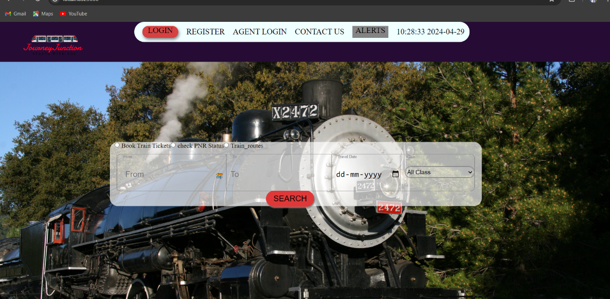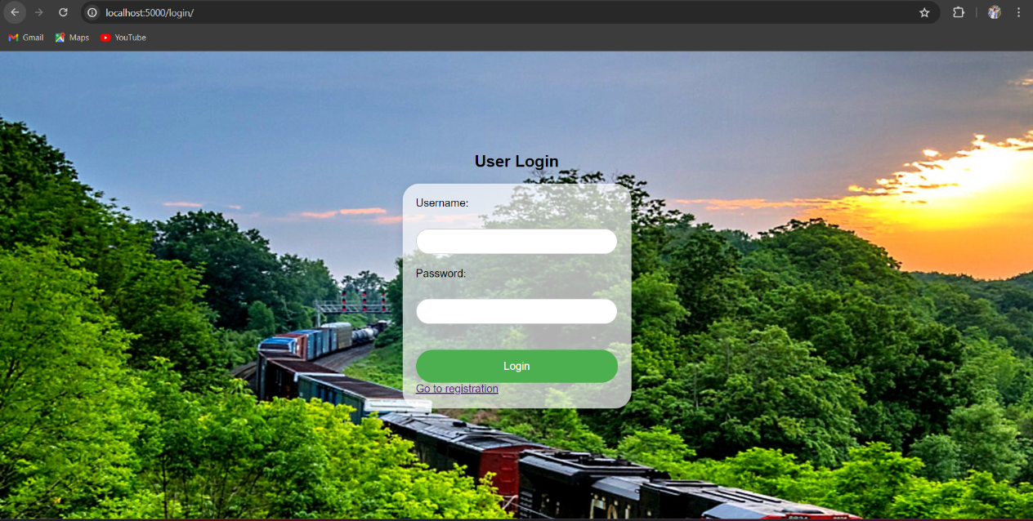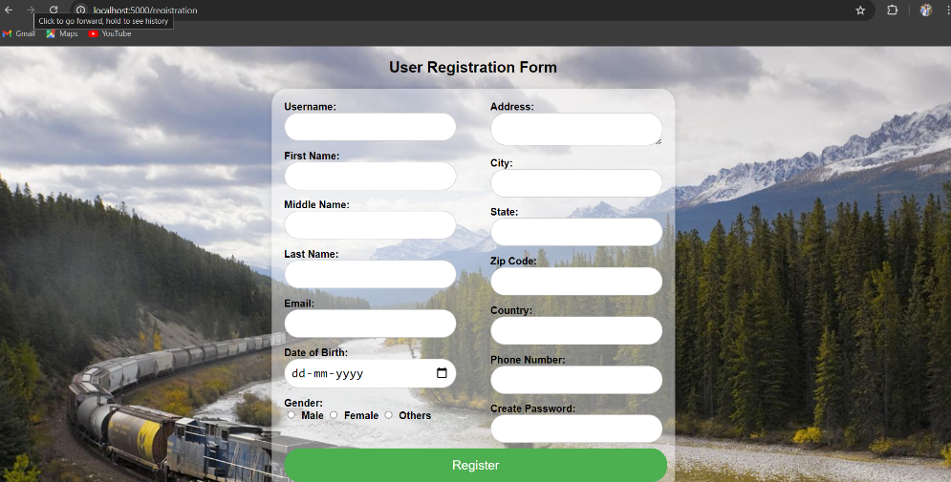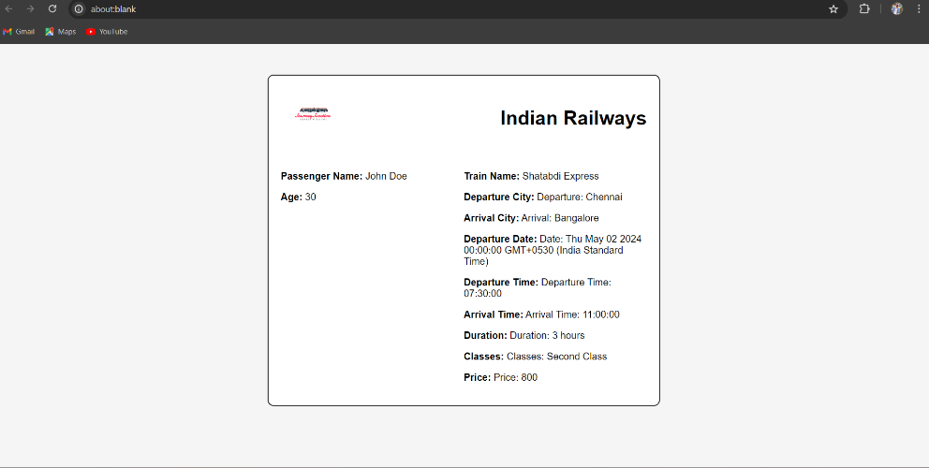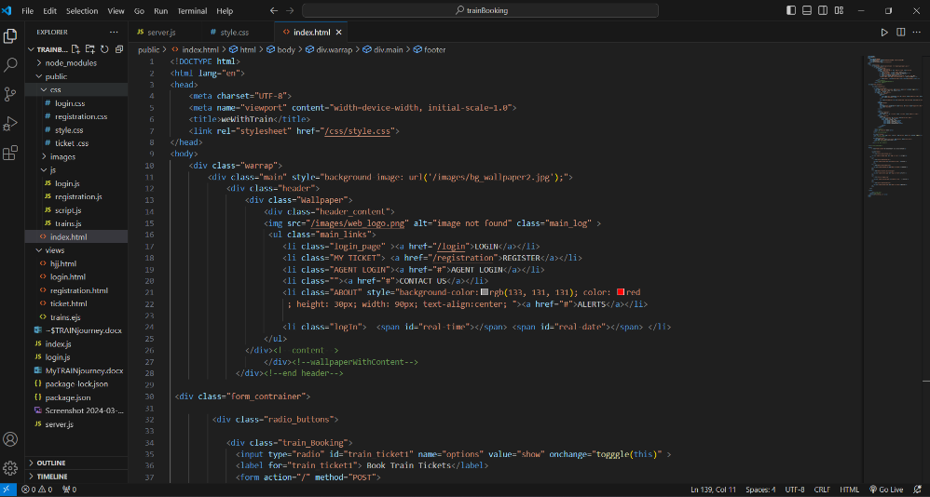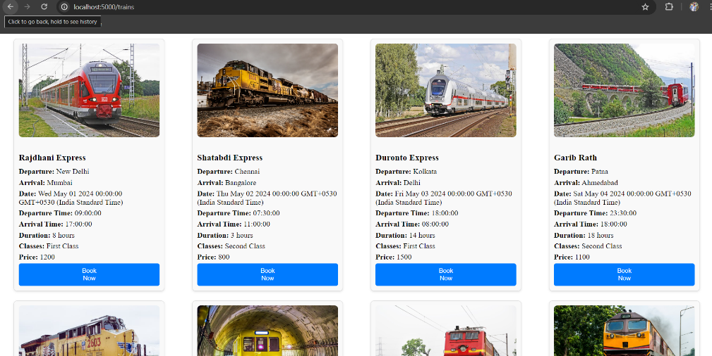

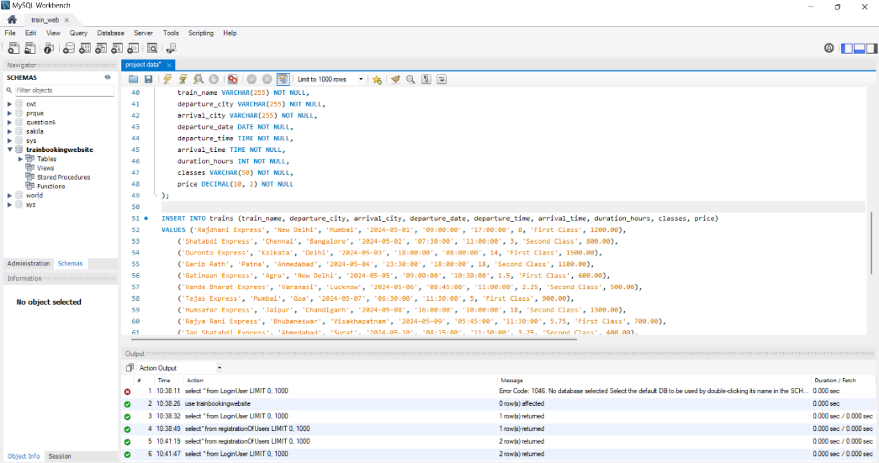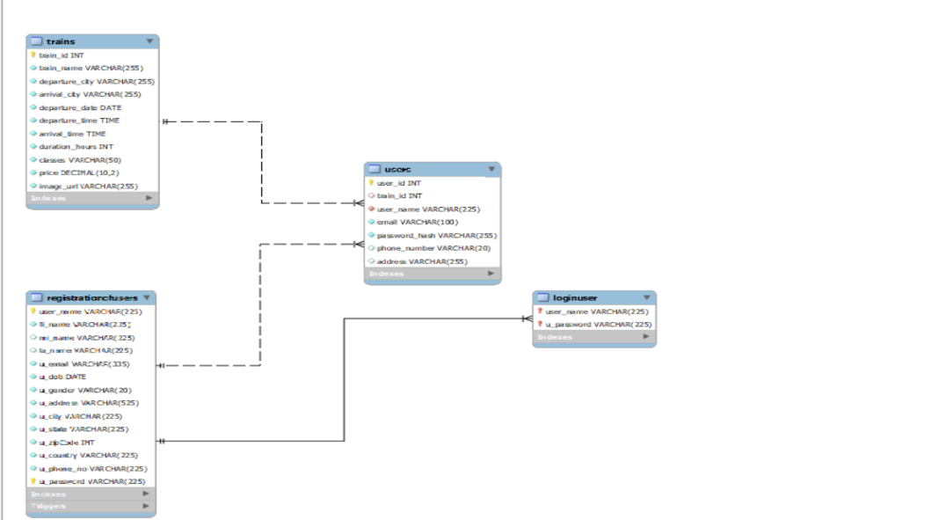

**ER DIAGRAM:**

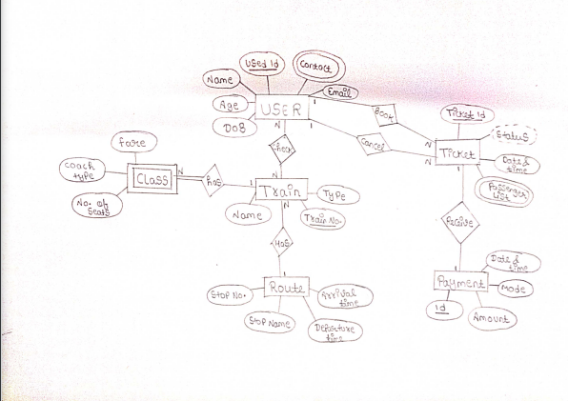

**Concussion:**

"A comprehensive train ticket booking website offering seamless user registration, login, and ticket booking. Users browse train schedules, select classes, and book tickets effortlessly. The system manages orders, carts, and user profiles efficiently. With a user-friendly interface and secure payment processing, it provides a hassle-free experience. Real-time train information and personalized ticketing enhance user satisfaction. Advanced features like seat selection and booking history add convenience. Overall, it's a reliable platform ensuring smooth travel planning and ticket management for railway passengers.